**CHAPTER ONE**

**INTRODUCTION**

**1.1 Background of the Study**

In the contemporary landscape of sports management, the integration of technology has revolutionized how sporting organizations operate, manage data, and optimize their processes. The realm of youth sports, including football, is no exception to this transformation. With its rich history and commitment to nurturing young talent, Kaduna Football Club recognizes the need to embrace technological advancements for efficient youth sports registration and player screening. Youth sports programs play a pivotal role in not only identifying promising athletes but also in instilling values such as teamwork, discipline, and sportsmanship in budding talents. However, the administrative aspects of managing youth registrations, screenings, and talent development have often been characterized by manual processes, paperwork, and potential inefficiencies. Montellano et al. (2019).

Youth sports play a vital role in the development of physical fitness, teamwork, discipline, and character in young individuals. In the vibrant city of Kaduna, Nigeria, football is not just a sport; it's a way of life. The Kaduna Football Club, a prominent entity in the local sports community, has a rich history of nurturing young talent and providing opportunities for the youth to participate in the beautiful game. (Nugraha, 2020)

As youth sports continue to grow in popularity and importance, ensuring a robust system for registration and screening is crucial. It not only benefits aspiring young athletes but also enables the club to identify and nurture talent more effectively. The success of such a system can have a far-reaching impact, potentially extending beyond Kaduna Football Club to influence youth sports management practices in the broader sports community. This study delves into the rationale, features, and expected outcomes of the proposed web-based system, shedding light on its potential to reshape the landscape of youth football and sports management in Kaduna and beyond. (Nugraha, 2020)

The proposed "Development of a Web-Based Youth Sport Registration and Screening System for Kaduna Football Club" aims to bridge this technological gap. It seeks to leverage web-based solutions to streamline and enhance the youth player registration and screening processes, ultimately contributing to the club's mission of talent development and creating a more efficient administrative framework.

**1.2 Statement of the Problem**

Kaduna Football Club grapples with inefficient manual processes for youth player registration and screening, impeding talent development and administrative operations. The existing system relies heavily on paperwork and manual data entry for youth player registration and screening, creating a range of inefficiencies and hindrances in the talent development process. The absence of a modern web-based system hinders the club's ability to streamline these critical aspects of youth sports management.

**1.3 Aim and Objective of the Study**

The project is aimed at developing a web-based youth sport registration and screening system for the Kaduna Football Club.

**Objectives**

In other to achieve the aim of this project the following objectives are set and considered relevant for the achievement. This includes:

1. To reveal the related literature on web-based youth sport registration and screening systems.
2. To design a web-based youth sport registration and screening system.
3. To implement the system and evaluate his efficiency in terms of system information needs / output.

**1.4 Scope of the Study**

This project is entirely centered on the development of a youth sports registration and screening system. Its primary objective is to streamline the process of registering young individuals for football-related activities and to manage their information efficiently and systematically. This study wouldn’t go beyond this.

**1.5 Limitations of the Study**

This study's scope has been constrained by several issues, including:

**Time** - The researcher's busy academic pursuits severely limited the time allotted for research for this study.

**Finance** - The need for a standard working personal computer unit to execute and debug the application software, hindered the quick and simple progress of the task.

**1.6 Significance of Study**

The significance of this study lies in its potential to revolutionize the efficiency and organization of youth sports registration and information management within Kaduna Football Club. By developing a streamlined web-based system, the project aims to enhance the club's ability to identify and nurture young talent while maintaining data in an orderly manner. The successful implementation of this system has broader implications, as it may serve as a model for other sports organizations, contributing to the advancement of youth sports management practices beyond the club's borders.

**1.7 Project Organization**

The project is divided into three chapters. The outlines are presented below:

**Chapter One: Introduction**

Chapter one introduces this project work, the background of the study, the statement of the problem, the aim and objectives, the scope of the study, limitations of the study, the significance of the study, project organization, and the definition of terms.

**Chapter Two: Literature Review**

This chapter focuses on the literature review, and the contributions of other scholars on the subject matter being discussed.

**Chapter Three: Methodology and Design**

This chapter is concerned with the presentation of the results of system analysis and design. It presents the research methodology used in the development of the system to facilitate an understanding and effective future implementation of the system.

**1.8 Definition of Terms**

1. **Screening:** The procedure of assessing and evaluating the skills, capabilities, and potential of young athletes, often conducted as part of talent identification and development. In the context of the project, screening refers to the evaluation of youth players for their suitability and potential within the Kaduna Football Club.
2. **Web-based:** Refers to a system or platform that operates on the internet and can be accessed through web browsers, enabling users to interact with and manage information online**.**
3. **Registration:** The formal process by which young individuals express their intent to participate in sports activities, particularly football, under the Kaduna Football Club. This process involves the provision of personal details and relevant information to the club's authorities, enabling the organization to record and manage their participation in an orderly manner.
4. **User interface (UI):** The part of a software application that the user interacts with, including the layout, buttons, and other elements**.**
5. **User experience (UX):** The overall experience of a user interacting with a product or service, including their emotions, perceptions, and behaviours**.**

**CHAPTER TWO**

**LITERATURE REVIEW**

**2.1 Introduction**

The purpose of this chapter is to show how the problem under consideration relates to prior research, current practice, or other fields of knowledge by citing relevant works by other researchers who have dealt with a similar issue. Furthermore, this chapter will include a synthesis of current research on the issue, highlighting areas of agreement, disagreement, and gaps in the literature, to establish the significance of the project topic in the field and to recommend opportunities for future study.

**2.2 Literature Review**

Montellano (2019). Development of Athlete’s Registration Management and Monitoring System. The study focuses on the development of an athlete's registration management and monitoring system for the University of the East's PE Department, aimed at streamlining the registration process for student-athletes participating in the UAAP. This digital system replaces manual registration methods, offering a centralized platform accessible to student-athletes, parents, coaches, officials, and school administrators, reducing paperwork and traditional challenges. The system provides student-athletes with the ability to monitor their allowances based on training attendance and access important information such as sports schedules and extracurricular activities. Using the Waterfall Model for software development and collecting data through a survey questionnaire, the study concludes that the Registration Management and Monitoring System is highly favorable to its users, ultimately enhancing the efficiency of athlete registration and management processes at the university.

Moreso, in this study, the methodology involved a two-fold approach. Initially, respondents were tasked with using the developed system to evaluate its usability. Subsequently, they were provided with a questionnaire to assess the program based on their firsthand experience. The Waterfall Model was employed in the system's development, a process that comprises five key phases: (1) Requirements gathering, (2) Design, (3) Implementation, (4) Verification, and (5) Maintenance. This sequential model was iterated through several cycles until the researcher deemed the program complete and ready for deployment, ensuring a comprehensive and thorough development process.

In conclusion, the study's recommendations include collaborating with a Graphic Artist to enhance the system's user interface, improving real-time updates and mobile application features, optimizing memory usage, seeking support from sports experts for school sports promotion, and implementing a data-driven athlete monitoring dashboard, all aimed at advancing sports-related technological solutions. The research gap in this study is the need for further exploration of the long-term impact of the Athlete’s Registration Management and Monitoring System in university sports and marketing. The study establishes its user-friendliness but lacks an in-depth analysis of its effects on athlete performance and dedication over time, as well as its effectiveness in marketing and addressing departmental issues. Future research should delve into these aspects to better understand the system's role in achieving excellence in athlete management.

Nugraha (2020). Athlete Management Information System in KONI Karawang District**.** The Indonesian National Sports Committee, or KONI, plays a vital role in coordinating and nurturing athletes to achieve success in sports at regional and national levels. KONI Karawang, as an authorized organization, serves as the focal point for sporting activities in the Karawang district, providing a platform for talented athletes to further develop their skills. However, managing athlete data efficiently has become a challenge. To address this issue, an Information System has been developed, designed to streamline athlete data processing in Karawang. This system takes the form of a web-based application, utilizing PHP programming language and a MySQL database, to enhance the management of athlete data within KONI Karawang.

Furthermore, the methodology employed in this study involves the representation of results from a prior design phase, which is subsequently implemented into a website using PHP programming. Data collection consists of two main stages: observation and interviews. During the observation stage, supporting information related to athlete data within KONI Karawang district is gathered. The interview stage is focused on identifying user requirements for the development of the application. These combined methods serve to inform the creation and implementation of the program.

In conclusion, the system represents a valuable tool for athlete data management within the National Sports Committee of Karawang Regency. It is recommended that continuous monitoring and updates be conducted to ensure the system's optimal performance. Additionally, training and support should be provided to users to facilitate seamless adoption and utilization of the system. This proactive approach will help maximize the benefits of the Information System in addressing athlete data management challenges. While the study introduces a promising Information System for athlete data management in Karawang Regency, there is a research gap in the absence of a thorough evaluation of the system's real-world implementation and its long-term impact on athlete data management. Future research should focus on assessing the system's effectiveness, user satisfaction, and its ability to meet the evolving needs of the National Sports Committee.

Ali, Zeebaree, Mujdat & M.Sadeeq (2021). Web-Based Land Registration Management System. This thesis highlights the persistence of hardcopy-based land registration despite the technological era and advocates for Internet-based methods to enhance efficiency and communication in government sectors. It emphasizes the role of Information and Communication Technology (ICT) in developing electronic government systems, particularly E-Land-Registration (ELR). The study proposes an ELR system for the Duhok Land Directorate to reduce time consumption, and paper waste, and integrate with the broader E-government framework. It includes modules like Employee Registration, Estates Registration, Operation Type, Estate Owners, Estate Status, View Information, and Login Employee, with implementation using HTML, CSS, PHP, MySQL, JavaScript, jQuery, Ajax, and Bootstrap tools.

However, the methodology employed in the development of the EMLRS (E-Land Registration System) revolves around a three-layered architecture. The presentation layer, the topmost layer, incorporates various tools such as HTML, JavaScript (including Ajax and jQuery), CSS, and Bootstrap to create the user interface and ensure responsive web design. The business logic layer, situated beneath the presentation layer, manages the core functionality of the system, while the data layer, at the bottom, is supported by technologies like PHP and MySQL to handle data storage and retrieval. The design and implementation of the ELR (E-Land Registration) system leverage these technologies, ensuring an integrated and efficient web application infrastructure.

In conclusion, the study recommends that ongoing support and training be provided to users to ensure seamless adoption and utilization of the system. Additionally, regular updates and maintenance should be carried out to keep the system aligned with evolving technological advancements and user requirements. Future research could focus on assessing user satisfaction, system scalability, and its ability to adapt to changing regulations and requirements.

Menaspà, Menaspà, Clark & Fanchini (2018). Validity of the online athlete management system to assess training load. This study aimed to validate the quantification of training load, specifically session rating of perceived exertion (s-RPE), within an Australian Olympic women's water polo squad. It utilized a modified RPE scale collected via a newly developed online system, the athlete management system. Sixteen elite female water polo players participated, with 30 training sessions monitored. Heart rate data was collected during these sessions, and participants rated training intensity using the athlete management system's RPE scale. The study analyzed individual relationships between s-RPE and two other training load methods: Banister training impulse (TRIMP) and Edwards' method. The results demonstrated that the online athlete management system was a valid indicator of internal training load, making it a valuable tool for elite sports.

Moreso, the study involved 16 elite female water polo players, with 30 training sessions monitored, totaling 303 individual sessions. Heart rate data was continuously recorded during these sessions. After each training session, participants were instructed to rate the intensity using the athlete management system's modified RPE scale via an online application within 30 minutes of completion. Individual relationships between s-RPE and two other training load methods, Banister TRIMP and Edwards' method, were then analyzed to assess the validity of the s-RPE collected through the online system.

However, based on the study's findings, it is recommended that the athlete management system, with its online s-RPE assessment, be adopted and further integrated into elite sports training programs. The system has demonstrated its validity as an indicator of internal training load, and its use can enhance training load monitoring and management in elite sport settings. Moreover, coaches and sports scientists should consider implementing this system to optimize training programs and performance outcomes.

In conclusion, while this study successfully validates the use of the athlete management system for assessing s-RPE as an indicator of internal training load, there is a research gap in the need for longitudinal studies to assess the system's performance over an extended period.

Ibrahim & Mohamed (2019). Kindergarten Registration Management System (KREMS). The Kindergarten Registration Management System (KReMS) is a comprehensive system developed for a kindergarten in Dungun, aimed at streamlining the registration process. KReMS serves various user roles, including parents, administrators, staff, and teachers, and encompasses eight key modules, such as student registration, fee payment, report generation, and communication with parents. Developed using the Rapid Application Development (RAD) methodology, KReMS underwent evaluation by both experts and users. Expert evaluations indicated that the system's interface was attractive, while user feedback from 30 respondents revealed a positive perception of improved work efficiency, with a high mean rating of 4.36 (SD= 0.62).

Furthermore, the chosen methodology for the development of the Kindergarten Registration Management System (KReMS) is the Rapid Application Development (RAD) Model, which comprises four key phases: Requirement Planning, User Design, Construction, and Evaluation. The selection of the RAD model was motivated by its capacity to expedite system development. This model is well-suited for rapidly creating and refining software systems, aligning with the goal of accelerating the development process for KReMS.

In conclusion, based on the study's findings, the positive feedback from users, particularly regarding the efficiency construct with the highest mean rating, demonstrates the system's potential to significantly improve their work processes. To further enhance the system, the suggestions and comments from experts should be carefully considered and implemented. Additionally, continuous monitoring and user training can ensure a seamless adoption of KReMS within the kindergarten. Future research could focus on the system's usability and effectiveness over an extended period, including potential challenges encountered during its practical implementation. Exploring the scalability of KReMS for use in other kindergartens and educational institutions could also provide valuable insights into its broader applicability and areas for improvement.

**2.3 Summary of Related Literature Reviews**

|  |  |  |
| --- | --- | --- |
| **Author & Year** | **Title & Description** | **Merit and Demerits** |
| Montellano (2019). | Development of Athlete’s Registration Management and Monitoring System.  The study focuses on the development of an athlete's registration management and monitoring system for the University of the East's PE Department, aimed at streamlining the registration process for student-athletes participating in the UAAP. | The system streamline registration processes, reduce paperwork, and enhance efficiency.  The study lacks a thorough analysis of the system's long-term impact on athlete performance |
| Nugraha (2020). | Athlete Management Information System in KONI Karawang District**.**  This system takes the form of a web-based application, utilizing PHP programming language and a MySQL database, to enhance the management of athlete data within KONI Karawang | The system efficiently streamlines athlete data processing, enhancing the management of athlete information within KONI Karawang.  High Influx of user might make the system slow. |
| Ali, Zeebaree, Mujdat & M.Sadeeq (2021). | Web-Based Land Registration Management System.  This thesis highlights the persistence of hardcopy-based land registration despite the technological era and advocates for Internet-based methods to enhance efficiency and communication in government sectors. | The system effectively addresses the challenges of hardcopy-based land registration.  The study lacks a detailed assessment of user satisfaction, system scalability, and its adaptability to changing regulations. |
| Ibrahim & Mohamed (2019). | Kindergarten Registration Management System (KREMS).  The Kindergarten Registration Management System (KReMS) is a comprehensive system developed for a kindergarten in Dungun, aimed at streamlining the registration process | The system streamlined the registration process for the kindergarten.  System is tailored to a specific set of users. |
| Menaspà, Menaspà, Clark & Fanchini (2018). | Validity of the online athlete management system to assess training load.  This study aimed to validate the quantification of training load, specifically session rating of perceived exertion (s-RPE), within an Australian Olympic women's water polo squad | The study establishes the validity of the online athlete management system in assessing training load.  The demerit is the need for longitudinal studies to assess the system's performance over time. |

**2.4 Analysis of the Current System**

The current youth player registration and screening system at Kaduna Football Club faces significant challenges due to its reliance on manual processes and paperwork. This manual system is inefficient, leading to delays and potential errors in the crucial processes of youth player registration and screening. Moreover, the use of a paper-based system poses risks such as physical damage or loss of important documents, threatening the integrity and availability of youth player information. Accessibility to information is limited, hindering stakeholders like coaches, administrators, and parents from promptly accessing necessary data. Manual data entry increases the likelihood of errors and discrepancies, impacting the accurate assessment of youth players. As the number of youth players grows, the system's scalability diminishes, and managing the increasing volume of paperwork becomes resource-intensive. The lack of a centralized platform contributes to data silos, making it challenging to have a holistic view of youth player information. Additionally, the absence of a modern web-based system represents a technological gap, impeding the club's ability to leverage technology for streamlined processes, efficient information management, and enhanced talent development. Addressing these challenges necessitates the development and implementation of the proposed web-based youth sport registration and screening system.

**2.5 Analysis of the New Proposed System**

The proposed web-based youth sport registration and screening system for Kaduna Football Club offer a transformative solution to the existing challenges in the current manual system. This modern system aims to streamline and enhance the youth player registration and screening processes, introducing efficiency and organization into the administrative framework. The new system leverages web-based technology, eliminating the reliance on manual paperwork and introducing a centralized platform accessible to various stakeholders, including coaches, administrators, and parents. By transitioning to a digital system, the proposed solution addresses the inherent problems of delays and potential errors in the current processes. The web-based nature ensures real-time accessibility to youth player information, facilitating prompt decision-making and communication. The system's design includes features for efficient data entry, reducing the likelihood of errors and discrepancies in youth player assessments. The scalability of the proposed system is enhanced, accommodating the growing number of youth players without a proportional increase in resource demands. The centralized platform breaks down data silos, providing a comprehensive view of youth player information.

**CHAPTER THREE**

**Methodology and Design**

**3.1 Introduction**

A methodology is a rigorous study or inquiry, particularly to unearth new facts or information; thus, research methodology should be good enough to enable the achievement of the specified objectives, which are achievable using specific components, such as data collection and design procedures, and system modeling (use case, activity, and class diagrams). This chapter provides the input/output specifications as well as the system requirements for developing a web-based youth sport registration and screening system for the Kaduna Football Club.

**3.2 Methods of Data Collection**

Before constructing any system, it is necessary to collect data and facts about the existing system to comprehend what is going on. Two approaches were used in this study.

1. Observation of the Work Environment
2. Documentation

**3.2.1 Observation of the Work Environment**

By monitoring how the manual system worked, this method was employed to acquire information and data for this study. A careful review highlighted the most evident flaws in the current system. When utilizing the observational approach, the environment in which the observation is taken can be changed in a variety of ways.

**3.2.2 Documentation**

Documentation is part of secondary data collection. In this case, journals, manuals, past work, publications, and other sources are utilized. This method of data collection was chosen because it allows for comparison with past studies. This includes the internet, which is a data collection tool. The internet was used to study difficult or ambiguous situations.

**3.3 System Modeling**

A system model is a conceptual model of a system that explains and depicts it. A system is any interaction between a group of components that work together to achieve a common purpose. A collection of visual notation techniques inherent in the Unified Modeling Language, which was used to design this current system, may be used to construct visual models of object-oriented software-intensive systems. UML diagrams utilized in this new design include use case diagrams, class diagrams, and activity diagrams.

**3.3.1 Use Case Diagrams**

Use cases are groups of interactions between a system and a user. Use case diagrams are used to graphically portray the functioning of a system in terms of its actors, goals (expressed as use cases), and dependencies between those use cases.

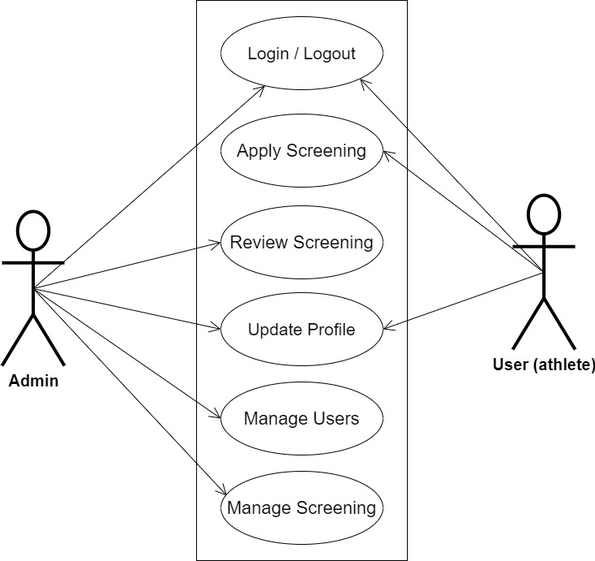

**Figue 3.1 System Use Case Diagram**

**3.3.2 Class Diagrams**

The Unified Modeling Language (UML) class diagram is an implementation of an independent view of how the system interface might appear, with each class having its own set of properties and displaying how they interact with one another. Class diagrams use the Unified Modeling Language standards to visually depict the static structure and composition of a given system (UML).

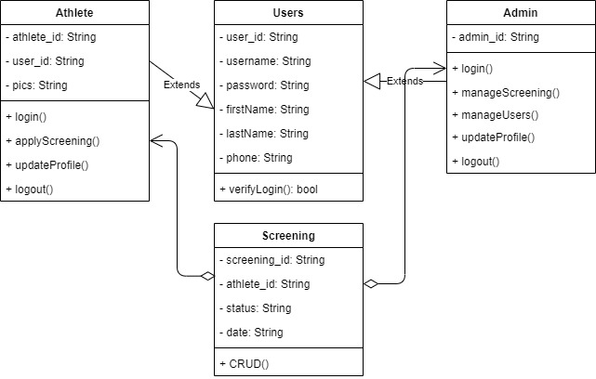

**Figure 3.2 System Class Diagram**

**3.3.3 Activity Diagrams**

An activity diagram, like a flowchart or a data flow diagram, visually illustrates a series of events or the flow of control in a system, but it acts more like an enhanced version of both.

**Login**

The process for gaining access to the system is depicted in the diagram below; the username and password must be accurate to gain access.

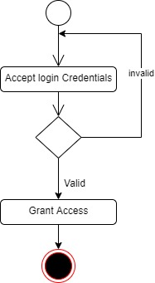

**Figure 3.3 Login Activity Diagram**

**Apply Screening**

The process for applying for screening by an athlete is depicted below, to apply for screening one has to be authenticated and must have proper authorization.

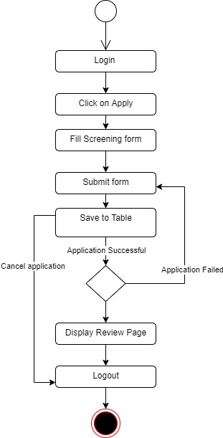

**Figure 3.4 Apply Screening Activity Diagram**

**3.4 Database Design**

Input specification is the logical explanation of how data is stored in the computer's memory. SQL standards are vital for guaranteeing that structured data is uniform and independent of applications due to the flexibility experienced when using the system, as well as the simplicity of accessing and reading the data and ensuring applicability throughout the internet. The following are some of the input specifications used in this project effort.

1. Users Table: contains basic information about all system users.
2. Screening Table: contains every system-saved screening information.

**Table 3.1 Users Input Specification Table**

|  |  |  |  |  |  |
| --- | --- | --- | --- | --- | --- |
| **Field Name** | **Data Type** | **Null** | **Key** | **Length** | **Description** |
| user_id | Varchar | No | PK | 32 | Unique string for identifying users |
| username | Varchar | No |  | 100 | Username |
| password | Varchar | No |  | 128 | User Password |
| firstName | Varchar | No |  | 60 | User first name |
| lastName | Varchar | No |  | 60 | User last name |
| phone | Varchar | No |  | 11 | User phone number |

**Table 3.2 Screening Input Specification Table**

|  |  |  |  |  |  |
| --- | --- | --- | --- | --- | --- |
| **Field Name** | **Data Type** | **Null** | **Key** | **Length** | **Description** |
| screening_id | Varchar | No | PK | 32 | Unique string identifying screening |
| athlete_id | Varchar | No |  | 32 | Unique string identifying athlete |
| status | Varchar | No |  | 5 | Screening status |
| date | Date | No |  | 20 | Creation date |

**3.5 Output Design**

This declares and displays the outcome of the given input. This automated system's output is dependent on its input. The output specification is listed below.

**Table 3.3 Users** **output design table**

|  |  |  |  |  |  |
| --- | --- | --- | --- | --- | --- |
| **User_id** | **Username** | **Password** | **FirstName** | **LastName** | **Phone** |
| XXXX | XXXX | XXXX | XXXX | XXXX | XXXX |
| XXXX | XXXX | XXXX | XXXX | XXXX | XXXX |
| XXXX | XXXX | XXXX | XXXX | XXXX | XXXX |
| XXXX | XXXX | XXXX | XXXX | XXXX | XXXX |

**Table 3.4 Screening** **output design table**

|  |  |  |  |
| --- | --- | --- | --- |
| **Screening_id** | **Athlete_id** | **Status** | **date** |
| XXXX | XXXX | XXXX | XXXX |
| XXXX | XXXX | XXXX | XXXX |
| XXXX | XXXX | XXXX | XXXX |
| XXXX | XXXX | XXXX | XXXX |

**3.6 Input & User Interface Design**

This is a graphic depiction of the system interface; it will be designed to be user-friendly, responsive, and visually beautiful. Furthermore, it will be fully secured, thus authentication will be required to see various levels of the information. To help with the designs, a mid-fidelity wireframing program called Draw.io is employed.

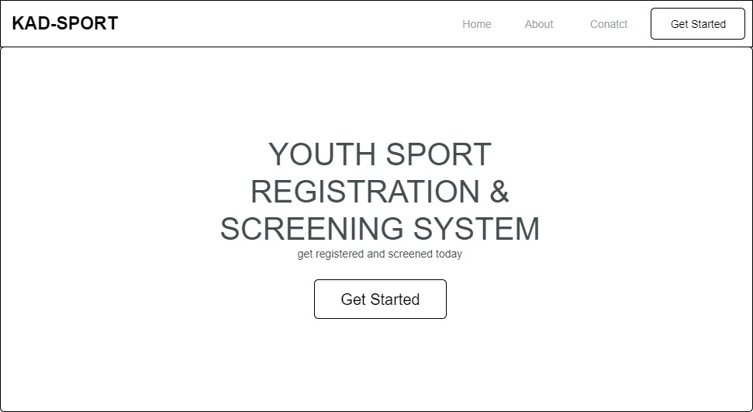

**Figure 3.5 Home Page**

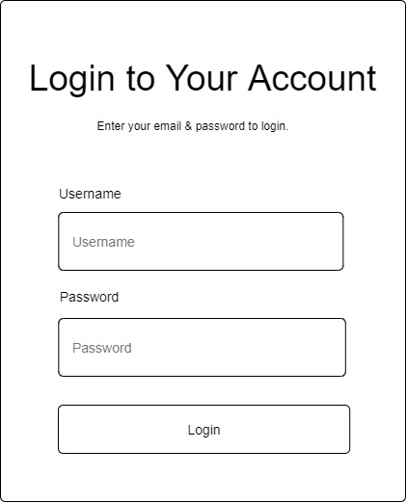

**Figure 3.6 User Login Screen**

**3.7 System Requirement**

Every piece of software has predefined system requirements that it must fulfill to function properly. The system requirements, on the other hand, are the bare minimum of hardware and software required for the system's intended operation.

**3.7.1 Hardware Requirement**

System Hardware requirements include:

1. Minimum of 2 GB of RAM (Random Access Memory).
2. Minimum of Intel Dual core processor.
3. Minimum of 250GB HDD (Hard Disk Drive).

**3.7.2 Software Requirement**

The software requirements include:

1. At least Windows 7 OS (Operating System).
2. Vs. Code IDE installation.
3. Browsers include Chrome and Firefox.

**3.8 Choice of Programming Language**

This research work will be a web-based application and will be implemented on a relational database system (SQLite). HTML (hypertext markup language), CSS (cascading style sheet), and JavaScript for the frontend development while Django (Python) will be employed for the backend programming.

**REFERENCES**

Ali Mohammed, H., Zeebaree, S., Mujdat Tiryaki, V., & M.Sadeeq, M. (2021). Web-Based Land

Registration Management System: Iraq/Duhok Case Study. Journal of Applied Science and Technology Trends, 2(04), 113–119. <https://doi.org/10.38094/jastt204113>

Ibrahim, A., & Mohamed, H. (2019). Kindergarten Registration Management System (KREMS).

International Journal of Advanced Science Computing and Engineering, 1(3), 162–168. <https://doi.org/10.30630/ijasce.1.3.22>

Nugraha, B. (2020). Athlete Management Information System in KONI Karawang District.

SYSTEMATICS, 2(2), 86–97. <https://doi.org/10.35706/sys.v2i2.3874>

Menaspà, M. J., Menaspà, P., Clark, S. A., & Fanchini, M. (2018). Validity of the online athlete

management system to assess training load. International Journal of Sports Physiology and Performance, 13(6), 750–754. <https://doi.org/10.1123/ijspp.2017-0379>

Montellano, J.M. (2019). Development of Athlete’s Registration Management and Monitoring

System. American Scientific Research Journal for Engineering, Technology, and Sciences, 34, 8-22.